Development Assessment Services
Department of Lands, Planning and the Environment
GPO Box 1680
Darwin NT 0801

Dear Sir
RE: Part Lot 5182 Dick Ward Drive
Previous correspondence with the Development Consent Authority (Ritchie 2010) has shown the Halikos stockpile to be illegal, although the “spokesman” for the leaseholders, Mr Michael Chin, claims the Gwalwa Daraniki Association asked for approval in 2006 and were told “there was no need to ask for permission” (Bevege 2013:23). If Michael Chin is correct, it is strange that no permission was needed to begin the stockpile of rubble from building sites on a community lease zoned CN Conservation (Langford 2010a:3; Doyle 2010d:18).

In response to queries from Margaret Clinch of PLAN, David Ritchie (2010), the then head of Department of Lands and Planning wrote:

The stockpile of fill located at Lot 5182 Dick ward Drive, Town of Darwin (Minmarama Estate) commenced in approximately November 2006. The placement of fill is understood to have originated through a private arrangement between the lessees (Gwalwa Daraniki) and a private construction company...

Clause 6.16 (Excavation and Fill) of the NT Planning Scheme requires the consent of the Development Consent Authority (DCA) for the stockpiling of fill and the Department has sought legal advice in relation to whether existing use rights apply to the stockpiling that occurred prior to February 2007. This advice has now confirmed that the stockpiling is not protected by existing use rights and the Department and DCA are actively seeking to have this use ceased and the site rehabilitated...

The DCA has recently issued a ‘Notice to Cease’ under the Planning Act for the stockpiling of fill and has requested that the owners provide a written response outlining a timetable for remediation...

The Department wrote to the lessee in November 2009 in relation to the placement of construction debris on the site. At the time the lessee provided an undertaking to remove the recent deposits of building rubble within 3 months. The Department will be following up the progress of the owner in complying with this request.

According to the NT News (Langford 2010b:7): “The rubble has come from development sites around Darwin through a deal brokered by estate agent Ernie Chin with the land’s leaseholder, the Gwalwa Daraniki Association.”

Ben Langford’s report (2010b:7) continues:

Mr [Ernie] Chin said developers Halikos had an agreement for depositing fill but did not think they would have to move it. I very much doubt it”, he said. “They put it there under license from the Aboriginal people who were told they could do it.”

Mr [Ernie] Chin said planning authorities were contacted before the dumping started and he was told there was no need for a permit....

Last year Planning Department chief executive Richard Hancock said a permit was not needed as much of the dumping happened before the start of the NT Planning Scheme in 2007.

But last week the department’s director of Development Assessment Services Steve Popple said the dumping must stop and the land would have to be rehabilitated.

Under the heading “Stench of evasion”, the columnist, Barry Doyle (2010d:18) reported in his usual forthright manner:

In October LAST YEAR Martin Bennett, a media liaison officer with the Planning Department, emailed Ben Langford of the NT News the following: ‘The majority of the fill was placed on site before the start of the NT Planning Scheme in 2007, which meant DCA approval was not required ... Association indicates that the fill RECENTLY (my capitals) [sic] placed on the stockpile will be removed within ... three months.’ Bennett said these weasel words should be attributed to Richard Hancock, CEO, Department of Planning and Infrastructure.

Doyle concludes with deep sarcasm: “There were no laws before 2007? ... A stench of evasion is in the air.”

According to Alison Bevege’s 2013 report (p.23), “...it is the builders Halikos Group that own the fill. Managing director, Shane Dignan said they would be using the rubble.” Bevege (2013:23) notes:

The DCA did not issue a Notice to Cease under the Planning Act until this year. When asked what enforcement action was taken the department said it had been ‘working with the landowner to facilitate removal of the fill from the property’. It is also suspending the enforcement action until the application process is finished.

An Exception Development Permit Application appeared in the NT News on April 19, 2013, page 40, (Second Advertisement) with closing date for submissions, Friday, 3rd May, 2013, 4pm CST.

Michael Chin, “the spokesman” for the Gwalwa Daraniki Association Inc (GDA) is also the lawyer who signed off on the amended constitution of the leaseholders. The GDA was granted the 301 hectare lease in 1979 for a peppercorn rental of ten cents per annum. It is significant that the land was not granted under the Land Rights (NT) Act, 1976, but was granted as a Special Purpose Lease. The grant followed an inquiry by the Interim Aboriginal Land Commissioner Judge Dick Ward in 1975. Ward had recommended that the land be held by a Trust for “Larrakia and Associated Aborigines”.

Aboriginal Land Rights Commissioner Woodward (1974:55-64) had previously documented the history of Bagot Reserve in nine pages of his final report. In 1977, Federal Cabinet papers cite this historical fact as a reason for granting the Kulaluk lease:

6. The immediate group of Larrakia people and their close relations is small, numbering only some 20 people, but Aboriginal visitors to Darwin camp in the area. In 1962 the then Government reduced the only Aboriginal reserve in Darwin – Bagot – from 640 to 57 acres to provide for urban development. The Aboriginal Land Rights Commissioner noted that the Kulaluk claim would partly compensate for this...

Before any consideration could be given to a hand back of the Kulaluk land, bureaucrats in the Department of Aboriginal Affairs (DAA) requested that the Gwalwa Daraniki Association submit future concept plans. Henderson (1984:27) quotes correspondence between the Darwin and Canberra offices of DAA:

In October [1974] a ‘proposed land usage plan’ for the whole [Kulaluk] area being claimed was received from Bill Day. Darwin DAA told Central Office [in Canberra]: ‘This includes large areas to be retained for public access as fauna and flora sanctuaries… We believe this proposal is imaginative and is an attempt to make the area at least partly into one of Aboriginal cultural significance. The fauna and flora sanctuary proposals may of course attract interest and support from environmentalists.

In Michael Chin’s amended GDA constitution, the association requires only “a minimum of 5 members” of which half must be Aboriginal. Members must also be members of the Danggalaba clan and reside on the lease for at least twelve months. Obviously the intention is to restrict membership. When asked in February 2013 why the constitution had been amended to allow a vote by “a minimum of five”, the past-president of the GDA, Mr Alan Treves, replied, “Otherwise we’d never get anything done.”

Objections to the use of community leases for economic advantage are expressed in the 1985 Hollingsworth Kulaluk study under the heading, ‘Socio-Political Ramifications’ (see Hollingsworth Consultants 1985:40). The section states:

During the course of the investigations undertaken as part of this study, several comments were raised against the concept of commercial development of leased Aboriginal land. One comment related to a perceived unfair economic advantage such development would have over competitors if it was developed for industrial uses. This advantage would arise because there would be no land cost component in the establishment of an appropriate rental for any such development. Such a cost component would undoubtedly be included in the rentals charged by the nearby industrial developments.

One other aspect which has been commented upon is the precedent that could be set by allowing commercial development of this leasehold land. Concern was expressed by an officer of the Department of Lands that if this development was to proceed, then the Department could expect to receive applications for commercial development from other Aboriginal communities on other lands leased for community or living purposes throughout the Territory. This was seen as being undesirable as it may, in turn, create a demand for further living areas.

In conclusion, my objections to the Exceptional Development Permit Application are summarised in the following brief bullet points:

- The stockpile was established on land granted to Aboriginal people as a conservation zone.
- The arrangement to establish the stockpile made between Halikos and the Gwalwa Daraniki Association is not transparent and has been found to be illegal.
- The stockpile interferes with the integrity and purpose of the lease.
- The stockpile interferes with access to the lease by Aboriginal people.
- The stockpile endangers the residents of the Minmarama Village through dust and air pollution and the movement of heavy vehicles through the village.
- The stockpile has no designated access roads, apart from the use of the Minmarama entrance onto Dick Ward Drive and the Minmarama internal roads. These roads are inadequate for residents’ vehicles, let alone heavy trucks.
- The stockpile contains building rubble, including concrete pours, demolition material and other unknown substances that are dumped unsupervised, and may contain asbestos waste.
- Aboriginal people with an interest in the area, such as the 1,600+ Larrakia people and the residents of the Bagot Community and Minmarama Village have no say in the controlling association, the Gwalwa Daraniki Association.
- The stockpile is incompatible with a Wilderness, Heritage, Culture and Education Park as originally proposed (see Day 2008).
- The stockpile on land granted for community use at a peppercorn rate gives an unfair economic advantage to Halikos and others taking advantage of cheap land and will be a precedent for other community leases to be used in contradiction to their original purposes.
- The proposed Exceptional Development Permit will be a subversion of justice, in that it legalises what was found to be illegal and covers over an apparent breach of the lease conditions.
- The Gwalwa Daraniki is already in breach of the permit to develop prawn ponds on the lease which later became a crab farm sponsored by the CDU. Both have failed. Under the permit, following the cessation of the aquaculture project, the area must be restored. This has not been done.

Yours sincerely
Dr William B Day
Consulting Anthropologist
Mobile: 0408 946 942

April 30th, 2013

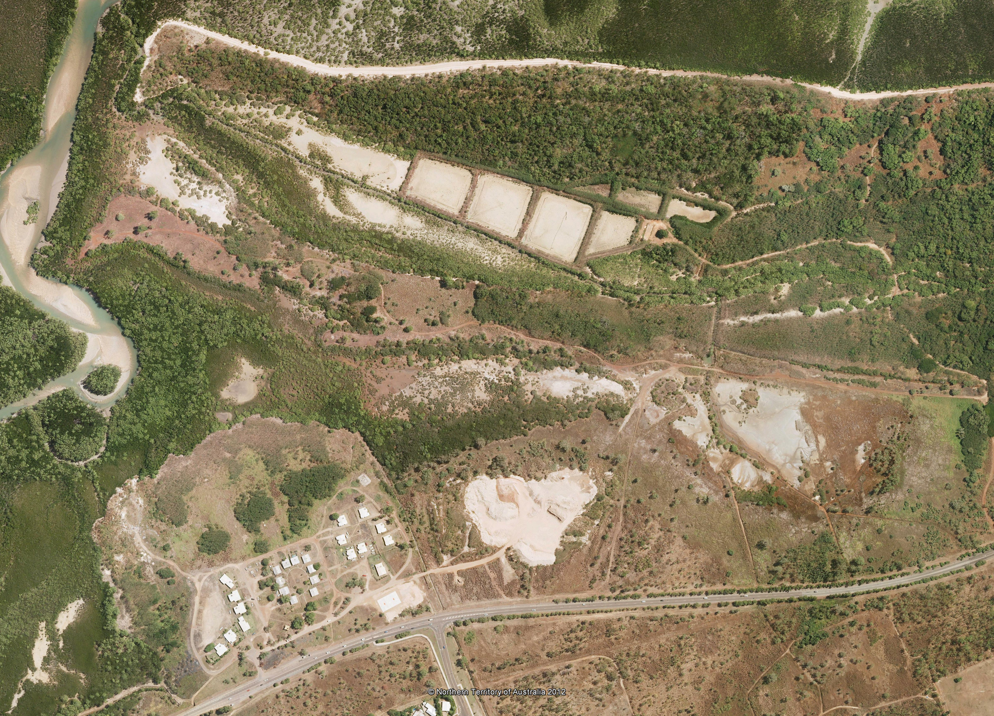
Above: Aerial view of stockpile showing Minmarama Village and abandoned aquaculture ponds on the Kulaluk lease.

References:
Bevege, Alison 2013 “Trouble with the rubble”, NT News, April 17, 2013, p. 23.
Cooper, C 1985 Submission to the Darwin City Council on Management Objectives for East Point Reserve. Aboriginal Sacred Sites Authority, Darwin.
Day, B 1994 Bunji: a story of the Gwalwa Daraniki Movement. Canberra: Aboriginal Studies Press.
Day, W B 2005 Shared Responsibility Agreement Alienates Land Won in Land Rights Struggle.
Day, W B 2006 Shared responsibility or no responsibility? The Kulaluk ‘Crabgate’ scandal. A5 Booklet, 8 pp.
Day, B 2008a A Bagot History. A4 duplicated booklet. 17 pages.
Day, W B 2008b Recommendations for a Kulaluk Wilderness, Heritage and Education Park: A last opportunity to be true to the vision of its founders? Report to Larrakia Nation Aboriginal Corporation.
Day, W B 2009 The Carve Up of Aboriginal Land in Darwin: behind the secret deals and crazy schemes: Government implicated. Duplicated A4.
Day, W B 2010 Kulaluk and Land Rights. Self published essay.
Doyle, Barry 2009a “Kept in the dark and fed at a late hour”, NT News April 2
2009b “Courtesy and reality crash on sea wall”, NT News April 9
2009c “Cooking up bold visions requires a deft touch”, NT News April 16.
2009d “Blinded by light of visionary short sight”, NT News May 28.
2009e “Sense and planning sensibilities on couch”, NT News June 18.
Doyle, Barry 2010a “Land rights wrongs”, NT News February 4.
2010b “Fed like mushrooms”, NT News February 11.
2010c “Twisted laws of the land”, NT News April 8.
2010d “Stench of evasion”, NT News April 15.
2010e “Mugged in the darkness”, NT News April 22.
2010f “Rich stench spreads”, NT News May 13.
2010g “Rabble with a cause”, NT News May 25.
2010h “Transports of delusion”, NT News June 3.
2010i “Women, children first”, NT News June 24.
2010j “Beware of the worms”, NT News July 7.
Gwalwa Daraniki Association Inc 1995 Our future at Kulaluk and Minmarama Park: Facts about the threats to our social and economic development.
Gwalwa Daraniki Association Inc and Vysrose Pty Ltd 1997 Kulaluk Development Proposal: development brief for the development Part Lot 5182, Bagot Road Town of Darwin.
Henderson, K 1983 Land Use Field Study of the Kulaluk Area. Darwin: Aboriginal Sacred Sites Protection Authority (unpublished).
Henderson, K 1984 History of the Kulaluk lease. Darwin: Aboriginal Sacred Sites Protection Authority (unpublished).
Hewitt, Sharon 2006 Our vision to economic independence and employment and educational opportunities for our community: an evaluation of Gwalwa Daraniki Enterprises Mud Crab Farm Employment Program. Gwalwa Daraniki Association Inc, Darwin.
Hollingsworth Consultants 1985 Kulaluk Lease Area Land Development Study, Brisbane: Hollingsworth Consultants in association with Planet Location International.
Langford, Ben 2010a “DCA orders molehill made of dirt mountain”, NT News, April 15, p. 3.
Langford, Ben 2010b “No one claiming big heap of rubble”, NT News, April 21, p.7.
Ward, D 1975 Kulaluk Land Claim: findings and report of the Interim Aboriginal Land Commissioner. Darwin: IALC
Woodward, A E 1973 First Report of The Aboriginal Land Rights Commission. Canberra: Australian Publishing Service
Woodward A E 1974 Final report of the Aboriginal Land Rights Commission. Canberra: Australian Publishing Service
Wells, S 1995 Town camp or homeland? A history of the Kulaluk Aboriginal community. Darwin: Report to the Australian Heritage Commission.

National Archives of Australia, Submission No. 1828: Kulaluk Land Claim, Darwin – Decision 4367 (GA) and 4367 (GA) Amended, Series A12909, Control symbol 1828, Barcode 8911869, p.7
T. C. Lovegrove to J. P. M. Long, 25 October 1974

